# Report for Brice Forrester (2024-10-01 to 2024-10-31)

Average Bat Speed: 47.37

Average Rotational Acceleration: 7.28

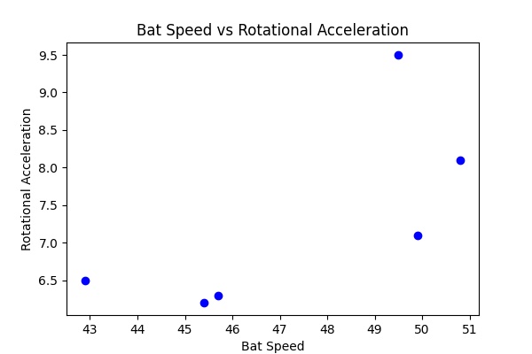

## Comments

Add comments here...